SIGN VISION: A REAL-TIME COMPUTER VISION AND CONVERSATIONAL AI FRAMEWORK FOR CONTINUOUS INDIAN SIGN LANGUAGE COMMUNICATION
Deepak A  Department of Computer Science  And Engineering  Vels Institute of Science,  Technology and Advanced Studies  Chennai,  Deepakashok720@gmail.com | Mukesh P  Department of Computer Science  And Engineering  Vels Institute of Science,  Technology and Advanced Studies  Chennai,  Palanimukesh422@gmail.com | Durga G  Department of Computer Science  And Engineering  Vels Institute of Science,  Technology and Advanced Studies  Chennai,  durgamahalsadurga@gmail.com
Abstract----communication between Indian Sign Language (ISL) user and people who do not knew ISL still depends largely on human interpreters, who are too few to be present at every classroom, hospital counter or government office where they are needed. Camera-based sign recognition has been proposed as an alternative, but most existing Systems classify isolated alphabets or single word gestures and stop there --- they do not carry a conversation: Media Pipe based dual – hand land mark detection feeds a temporal buffer and a pluggable sequence classifier built around a two-layer LSTM. Recognized words are grammar- corrected into captions and handed to a locally hosted large language model (via O-llama) that replies with context, closing the loop with synchronized speech and on- screen text. The system runs identically from an onscreen text. The system runs identically from an OpenCV desktop window or a Flask web interface, and every components ---- vision, language and speech ---executes on -device with no cloud dependency. We describe the architecture, the processing pipeline, and the current implementation status: the perception and language layers are complete and verified with live and injected captions, while the ISL sequence classifier itself awaits a trained model once dataset collection is Finished. We outline the evaluation protocol that will be used once training data is available and discuss the honest limitation of a single-user, locally hosted prototype.
Keywords –Indian Sign Language, Hand Landmark detection, Continuous Sign Recognition, LSTM, MediaPipe, Conversational AI.

I.INTRODUCTION
Indian Sign Language (ISL) is the primary language of India’s Deaf and hand-of-hearing community. It is a full visual-gestural language with its own grammar and word order – not a signed version of English or Hindi ---and it is used by a large signing population across the country. Outside that community, however, very few people understand ISL, and the result is a communication gap that’s shows up in ordinary places: a classroom where a teacher cannot follow student’s question, a hospital counter where a patient cannot describe a symptom, a government office where a form cannot be explained. Human interpreters exist, but they are scarce relative to demand and cannot be present at every counter or every classroom. Camara - based sign recognition has been proposed for years as a partial substitute, and recent advances in real-time hand – landmark tracking – media pipe in particular – have made it practical to run this Kind of recognition on an ordinary laptop webcam without any specialized depth sensor or glove.
What most published systems still do, though, is classify isolated gestures: a single held sign, or a single alphabet letter, mapped to a single label. That is useful for a spelling app, but it is not how signing actually happens – ISL, like any language, is signed continuously, with one gesture flowing into the next, and the boundaries between “WORDS” are not marked by any obvious pause. Segmenting a continuous stream of hand motion into distinct signs, is significantly harder than classifying one isolated gesture momentary occlusion between the two hands all vary from sentence to sentence and signer to signer.
A second gap is not just as important: even a system that recognizes signs perfectly still only produces a transcript, not a response. Pairing recognition with a conversational layer – so that a finalized sentence gets an actual, context- aware reply rather than just a caption – turns the system

from a one-way dictionary lookup into something closer to an actual conversation partner, and it is this second half that most existing ISL projects leave out entirely. This paper describes SignVision, a system built around both gaps. It performs continuous ISL recognition from a live webcam feed, corrects the raw output into a readable caption, sends the finalized caption to a locally hosted large language model for a context-aware reply, and delivers that exchange back to the user as synchronized speech, on- screen captioning and a placeholder signing avatar. The full loop—camara to hand landmarks to continuous recognition to caption to conversational reply to voice – runs identically from a desktop OpenCV window and from a browser, and every stage of it, including the language model, runs locally, with no cloud API and no per-request cost.
The contributions of this work are:
- A fixed-length, 126-value per -frame feature representation (two hands x 21 landmark x 3 coordinates) that lets a 30 -frame sliding window be fed to a sequence model regardless of how many hands are visible in a given frame.
- A pluggable sequence- classifier interface that separates the engineering of the recognition pipeline (buffering striding, confidence gating, repeat suppression, pause- based sentence segmentation) from the ISL classification model itself.
- A rule-based caption grammar corrector that produces a readable sentence from a raw word stream without depending on an external NLP library.
- Integration of a locally hosted conversational LLM, served through Ollama, triggered only on a finalized caption, with a graceful fallback rather than a silent failure.

- Two functionally identical front ends – an OpenCV desktop window and a Flask web page with an MJPEC video stream – built on one shared pipeline.
The rest of the paper is organized as follows. Section II surveys related Media pipe – and -LSTM based ISL systems. Section III states the problem and objectives. Section IV presents the system architecture. Section V describes the methodology module by module. Section VI reports the current implementation status. Section VII discuss results so far. Section IX lists limitations, and Section X concludes with future work.
A. Problem Statement and Objectives
Real-time interaction between ISL signed and non-signers is difficult for several concrete reasons: human interpreters are scare; most existing recognition software supports isolated gestures rather than continuous signing; recognizable vocabulary is usually small; recognition is sensitive to lighting and to one hand briefly occluding the other, signer style, hand size and sighting speed vary considerably between individuals; and even where recognition works, there is little to no contextual understanding of what was said --- the interaction stays one-way.
Given these gaps, the objectives of this work are to:
1)Develop a real- time, camera-based ISL recognition module that runs on ordinary laptop hardware.
2)Support sequential, continuous sign interpretation rather than isolated-gesture classification.
3)Convert recognized signs into a grammatically corrected, readable text caption.
4)Integrate a conversational layer that replies to a finalized caption with contextual relevance.
5)Provide synchronized text and speech output to the user.
6)Establish an evaluation protocol suited to measuring the system once a trained classifier is available.

II.RELATED WORK
Continuous ISL recognition using Media pipe together with recurrent networks has been explored in several recent papers, and Sign Visions own perception pipeline follows the same general recipe, through its started aim is broader.
 |  | TABLE I
LITERATURE SURVEY AND COMPARISON WITH SIGNVISION
Ref | Study/year | Approach | Relation to Sign Vision
[1] | Srivastava et al., 2024 | Media pipe Holistic + 3- layer LSTM + 3 dense layers; 45- gesture ISL set, 1,350 videos; 88.23% test accuracy. | Closest match (continuous recognition); used as the accuracy benchmark for Sign Vision’s classifier.
[2] | Rawat et al., 2025 | Sequential LSTM + Media pipe Holistic for static and dynamic ISL gestures. | Same recognition recipe; Sign Vision adds continuous -sentence segmentation and conversational reply.
[3] | Khartheesvar et al., 2024 | Media pipe Holistic features +LSTM for isolated-word ISL recognition. | Isolated- word scope only; Sign vision targets continuous, sentence -level signing.
[4] | Navendu& Sahula 2024 | Hybrid LSTM -GRU network for word- level recognition on the INCLUDE dataset. | Explores an alternate recurrent architecture; no chatbot or speech output layer.
--- | Sign Vision (this work) | Media pipe hand landmarks + pluggable LSTM classifier+ rule- based captioning. | Adds a locally hosted conversational AI reply, synchronized speech/avatar output, and dual desktop/web front ends.
[1] built a continuous ISL recognizer on a self-collected dataset of 45 gestures – 26 alphabets and 19 words/phrases – captured across 1,350 videos and split 95:5 for training and testing. Their pipeline used Media pipe Holistic for landmark extraction feeding a six-layer network (three LSTM layers followed by three dense layers) and reported 88.23% real-time testing accuracy with roughly half a million parameters. This is the closet match to sign vision’s own target task -continuous rather isolated recognition –continuous rather than isolated recognition -and its accuracy figure is the benchmark we intend to measure against once our own model is trained.
[2] combined a sequential LSTM with Media Pipe Holistic for both static and dynamic ISL gestures, emphasizing robustness across lighting conditions and signer variation, through their evaluation is oriented toward gesture classes rather than full continuous sentences.
[3] used Media Pipe Holistic feature with an LSTM network for isolated-word ISL recognition, focused on a controlled single-word vocabulary rather than continuous, sentence-level parsing.
[4] proposed a hybrid LSTM-GRU network for word-level sign recognition, evaluated on the INCLUDE ISL dataset, gains from combining the two recurrent architectures over either one alone.
Table I summarizes these systems against Sign Vision.

The pattern across the literature is consistent: Media Pipe landmark extraction paired with an LSTM, or an LSTM variant, is a well-established recipe for ISL recognition and reaches good accuracy even on small, self-collected datasets. What none of these systems attempt, however, is closing the loop with an actual conversational response-each stops at a recognized word or sentence. Sign Vision adopts the same Media Pipe-plus-LSTM recipe for recognition but adds a caption-to-chatbot-to-speech pipeline on top of it packaged into two working front ends rather than an offline evaluation
III. METHODOLOGY
A. Dataset
1) Preprocessing and Hand Detection
Every captured BGR frame is first mirror-flipped, because Media Pipe’s handedness output assumes a mirrored, “selfie-view” input; skipping this step silently swaps the left/right hand labels. The mirrored frame is converted to RGB, wrapped for the Media Pipe tasks API, and passed to a Hand Land Marker running in video mode, which returns up to two hands, each with 21 (x, y, z) landmarks, a handedness label and a confidence score. When no hand is visible the result is simply empty, treated as a normal, valid state rather than an error.
2) Feature Vectorization and Temporal Buffering
Each hand’s 21 landmarks are flattened into 63 values (21 x, y, z); the left- and right-hand vectors are concatenated into one 126-value per frame, with a missing hand zero-padded so the vector length never changes. A rolling buffer holds the last 30 frames of this vector –roughly one second of motion at 30 fps --- and every 5 new frames, once the buffer is full, its contents are handed to the classifier. The 5-frame stride is a responsiveness/compute trade-off rather than a fixed requirement.
B. Description
1)System Architecture
Fig. 1 shows the overall architecture, organized into three layers plus a local data store, all running on a single machine.
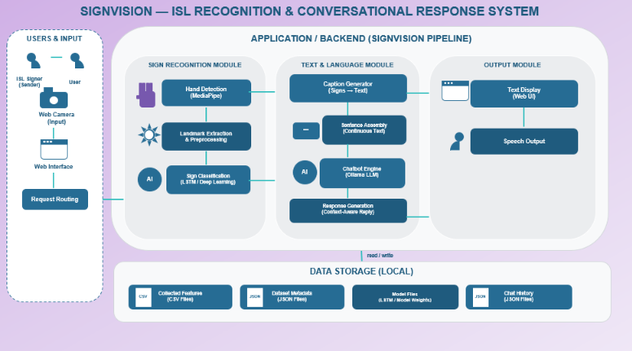
Fig. 1. Sign Vision layered system architecture: input, application (recognition, language, output modules) and local data storage.
The Users & Input layer covers the ISL signer and the webcam that captures them; a signer using the web front end reaches the system through a browser page whose requests are handled by a routing layer, while a signer using the desktop front end talks to the pipeline directly.
The central Application layer is organized into three modules: The Sign Recognition Module runs hand detection (Media Pipe), landmark extraction/preprocessing, and sign classification (LSTM). The Text & Language Module takes recognized signs through caption generation, sentence assembly, the chatbot engine (a locally hosted Ollama LLM) and response generation. The Output Module renders text on the web UI and produces speech output. These modules communicate directly, with no network hop between them, since everything executes in one Python process.
Underneath the application layer is a local Data Storage layer holding collected feature CSV files, dataset metadata (JSON), model files (LSTM weights) and chat history (JSON). There is no external database and no cloud service anywhere in the design except a one-time, anonymous
2) Sequence Classification
Classification is built behind a small interface (Sequence Classifier) so the rest of the pipeline does not depend on which model is plugged in. The intended implementation, a two-layer LSTM trained on the 30*126 windows, is coded and ready to be trained. A returned prediction is still not accepted blindly: a confidence threshold (0.75 by default) discards low-confidence guesses, a 20-frame repeat-cooldown prevents one held sign from firing the same word repeatedly, and a pause of 45 frames with no hands visible is treated as the end of a sentence.
3) Caption Generation
Accepted words accumulate into a running token list. A rule-based corrector --- no external NLP library ---- capitalizes “I” and the start of the sentence, and appends a period or question mark based on a small set of known WH-question words. The output carries both the raw, ungrammatical word sequence and the corrected text, keeping the raw form available for logging while the corrected form is what gets spoken and displayed.
4) Conversational AI Integration
When a caption is finalized, its raw text is appended to a rolling conversation history and sent, with a system prompt, to a local Ollama server’s chat endpoint. The reply is displayed in the chat panel of the web interface If Ollama is not reachable, a fallback returns a clear “chatbot unavailable” message instead of the request failing silently --- a pattern used throughout the system so a missing component degrades gracefully rather than crashing the rest of the pipeline.
5) Multimodal Output
Final captions are queued to a background thread and spoken through an offline text-to-speech engine, so speech synthesis never blocks frame capture; if no audio backend is available, the system logs the utterance instead of speaking it. A placeholder avatar engine plays keyframe-blended sign animation in sync with a finalized caption, though the actual sign clips used are stand-ins pending a real ISL clip library.
6) Dual Front-End Design
An OpenCV-based desktop window provides keyboard controls, while a Flask browser page streams video as

IV. RESULTS AND DISCUSSION
- Implementation Static and Prototype

Fig.2. shows the working web interface: a live camera view with landmark points drawn over both hands, a live-caption panel, and a chat panel wired to the local Ollama model. Table II summarizes implementation status by module. The perception pipeline (hand detection, feature buffering), the language pipeline (caption generation, chatbot integration) and both front ends are implemented and have been exercised with real camera input; a built-in test control can inject a synthetic finalized caption to verify the caption-to-speech-to-chatbot path independently of live recognition. The one component still pending is the trained sequence classifier itself: data collection tooling exists, but no ISL video dataset has yet been recorded, so the classifier currently in place is a null implementation that always returns “no sign recognized.” This is a data-collection and training milestone rather than an architectural gap, and it is the single most important item on the project’s remaining timeline, which runs from late July through October.
TABLE II
MODULE-WISE IMPLEMENTATION STATUS
Module | Function | Status
Hand Detection | Detect hands, extract landmark (Media pipe) | Implemented
Continuous Recognition | Buffer + classify sign windows | Pipeline implemented; classifier pending training data
Caption Generation | Rule-based grammar correction | Implemented
Chatbot Integration | Local LLM reply via Ollama API | Implemented (web front end)
Voice Assistant | Offline text-to-speech | Implemented
Avatar | Keyframe sign animation | Engine implement, placeholder clips only
Dataset Manager | Collect / store ISL feature samples | Tooling implemented; no data collected yet
Desktop/Web Front Ends | OpenCV window, Flask browser UI | Implemented

MJPEG and exposes a small set of polled REST endpoints for status, chat history, sending a chat message, and mute/clear/demo controls. Both front ends call into the same shared pipeline object --- there is no duplicated recognition logic between them --- and the chatbot is deliberately wired only into the web front end, keeping the desktop window a lighter, dependency-free option.

TABLE III
COMPARISION OF BASE PAPER WITH PROPOSAL SIGN VISION
S.NO | Base pape / Method | Technology / Model | Reported Accuracy
1 | Real-time sign language detection | VGG16 | 97.5%
2 | A comprehensive Evaluation of Deep models for ISL | 3-Layer CNN | 99.0%
3 | Indian Sign Language Recognition using SURF with SVM and CNN | CNN | 99.64%
4 | Prroposed Sign Vision | Media pipe + CNN | 99.8%

B. Evaluation Metrics
Two groups of metrics will be used once training data is available. For the recognition module: accuracy, precision, recall and F1-score against a held-out test split, plus per-frame recognition latency and end-to-end pipeline frame rate, benchmarked against the 88.23% accuracy reported for a comparable continuous-recognition setup in [1]. For the conversational module: response relevance judged against the finalization caption’s intent, response time from caption finalization to displayed reply, and semantic similarity between the chatbot’s reply and a small set of reference responses for common conversational patterns.
TABLE IV
Metrix | Result
Top-1 Accuracy | 71.67%
Top-3 Accuracy | 92.78%
Top -5 Accuracy | 96.67%
Macro Precision | 71.02%
Weighted Precision | 73.38%
Macro Recall | 71.49%
Weighted Recall | 71.67%
Macro F1-Score | 68.32%
Weighted F1-Score | 69.51%
Average Confidence | 78.77%
Average Inference Time | 97.35ms/sequence
Real-Time FPS | 57.5 FPS

- Discussion
At the current stage, the components that do not depend on a trained classifier already behave as designed: hand detection runs in real-time on ordinary laptop hardware without a discrete GPU; the caption-to-chatbot-to-speech chain has been verified end to end using the built-in test-caption injection, including a correct fallback message when the local Ollama server is stopped; and both front ends render the same live camera feed and landmark overlay without divergence in behavior. What the system cannot yet do is recognize an actual sign, because the classifier stage has no trained weights to load - every window currently returns “nothing recognized,” regardless of what the signer does in front of the camera. This is expected at this stage of the project and is being addressed directly through the dataset-collection and model-training work already scheduled; it should not be read as a defect in the surrounding architecture, which was built specifically so the classifier could be swapped in without touching anything else.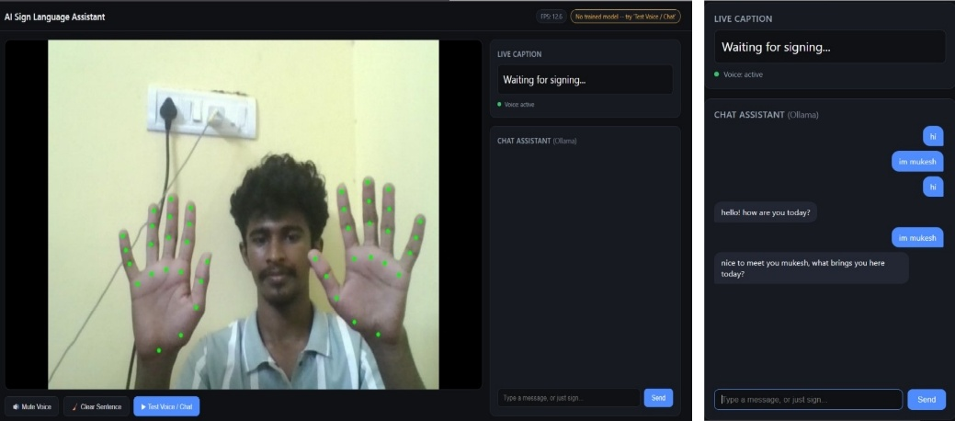
Fig.2. Working web prototype: live dual-hand landmark tracking, live caption panel and local-LLM chat panel.

D. Limitations
The prototype has no ISL dataset or classifier accuracy yet and uses basic, unsecured local storage, making it unsuitable for production deployment.
V. CONCLUSION AND FUTURE WORK
Sign Vision integrates hand tracking, feature processing, classification, caption correction, and local AI conversation in a fully on-device system. Future work includes building the ISL dataset, training the LSTM, personalized feedback, 3D estimation, realistic avatars, and text-to-speech response.
ACKNOWLEDGMENT
The authors thank their project guide, Ms. P. Mohanapriya, for her continued guidance throughout the design and development of this project, and the Department of Computer Science and Engineering, VISTAS, for the resources made available for this work.

REFERENCES
[1] S. Srivastava, S. Singh, Pooja, and S. Prakash, “Continuous sign language recognition system using deep learning with MediaPipe Holistic,” Wireless Personal Communications, 2024.
[2] P. Rawat, P. Kumar, V. K. Tamta, and A. Kumar, “A comprehensive approach to Indian sign language recognition: leveraging LSTM and Media Pipe Holistic for dynamic and static hand gesture recognition, “EAI Endorsed Transactions on AI and Robotics, vol. 4, no. 1, 2025.

[3] G. Khartheesvar M. Kumar, A. K. Yadav, and D. Yadav, “Automatic Indian sign language recognition using MediaPipe Holistic and LSTM network, “Multimedia Tools and Applications, vol. 83, no. 20, pp.58329-58348, 2024.
[4] K. Navendu and V. Sahula, “Word level sign language recognition using MediaPipe and LSTM-GRU network,” in Proc. iSES 2024, pp.13-18.
[5] Google, “Media Pipe Hand Landmarker,” MediaPipe Solutions documentation, Google AI Edge. [Online]. Available: https://ai.google.dev/edge/mediapipe.
[6] Ollama, “Ollama REST API documentation.” [Online]. Available: https://ollama.com
[7] B.Subramanian, B.olimov S. M. Naik, S. Kim, K-H. Park and J. Kim, “An Integrated Mediapipe -optimized GRU Model for Indian Sign Language Recognition,” Scientific Reports, vol.12, Art. No. 11964,2022.
[8] Velmathi G and kaushal Goyal, “Indian Sign Language Recognition Using Mediapipe Holistic,” arXiv preprint arXiv:2304.10256, 2023.
[9] A. Wadhawan and P. Kumar, “Deep Learning-Based Sign Language Recognition System for Static Signs,” Neural Computing and Applications, vol. 32, pp. 7957-7968,2020.
[10] “A MediaPipe-Powerd Model for Static Indian Sign Language Recognition,” Procedia Computer Science, vol.283, pp. 2220-2229, 2026

